NPN & PNP BJT OVERVOLTAGE PROTECTION CIRCUITS:
[A] PNP BJT OVERVOLTAGE PROTECTION CIRCUIT:
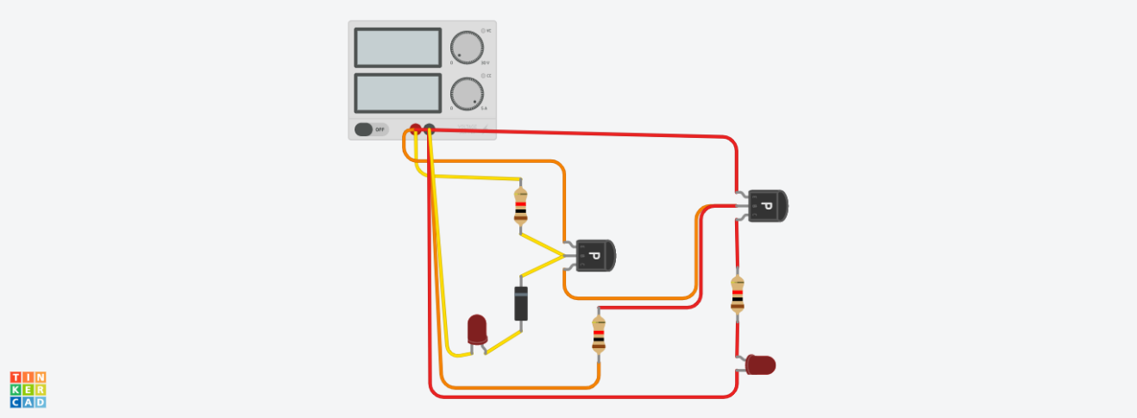
Circuit link:
https://www.tinkercad.com/things/iPo7B6pyj6W-pnp-bjt-overvoltage-protection-circuit/editel?returnTo=%2Fdashboard%2Fdesigns%2Fcircuits&sharecode=Xw9J3mZukvpUiDc_YDamaTuaV1PQS7espykGLmKtEUY
ZENER DIODE:
Zener diode is a special diode that is designed to work in reverse bias, when a certain Zener voltage is reached.it tries to clamp the voltage across it at its Zener voltage.
PNP BJT:
PNP BJT (bipolar junction transistor) allows current to flow from emitter to collector when the base is slightly more negative than the emitter, this means it is on when the base is pulled low and turns off when base is closer to supply voltage. That is why the transistors here are connected directly to the supply so it acts as a high side switch.
How the circuit works:
The yellow loop shown above is a voltage regulator that uses the Zener diode to regulate the voltage reaching the first PNP BJT. While the input voltage is less than the Zener voltage the Zener diode blocks the current and so the base of the PNP receives current and does not conduct then no current is passed to the second transistor so it acts as a closed switch suppling current to the load(LED and the resistor).
if the Zener voltage is exceeded then the Zener diode passes the current leaving no current in the first PNP BJT transistor, this causes it to act as a closed switch and so current flows to the base of the second transistor which leads to disconnecting of the load. Note that in this case the LED in the yellow loop will show that current is passing through the Zener diode.
[B] NPN BJT OVERVOLTAGE PROTECTION CIRCUITS:

Circuit link:
https://www.tinkercad.com/things/7UCvzuRKtFU-npn-bjt-overvoltage-protection-circuit/editel?returnTo=%2Fdashboard%2Fdesigns%2Fcircuits&sharecode=IzMCMliDFC7eFV1HoiTHhh1Hvb3PUCbSQ8tBtK6bEaY
NPN BJT:
NPN BJT transistor allows current to flow from collector to emitter when a small current is supplied to the base it turns on when the base is slightly more positive than the emitter and turns off if it is at the same potential as the emitter ;since the base should be higher in potential for it to operate it is used as a low-side switch in the circuit and is placed after the load(LED and resistor).
How the circuit works:
Instead of a voltage regulator circuit, a voltage divider circuit is used here in the first loop, the values of resistances control the voltage limits allowed. Now at high voltage, when the base pin of the first transistor is sufficiently more positive than the emitter pin (typically higher by 0.7v),the transistor turns on and passes current to ground, the base of the second NPN BJT has no current to it and so it so acts as an open switch, disconnecting the load from the supply.
On the other hand, when the voltage is not high enough there is not enough of a positive difference in potential in the first transistor so it acts as an open switch, current is passed to the base pin of the second resulting in positive potential difference between the base pin and the emitter pin of that NPN BJT so it acts as a closed switch and the load operates normally.

